 | Grace Smiley
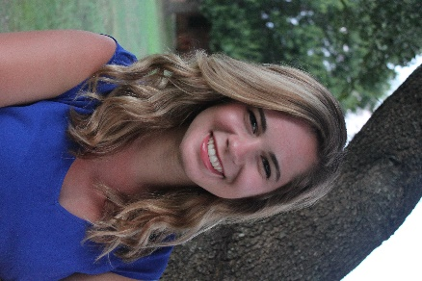 | 304-444-3181  dsmiley2@radford.edu  Radford University  BS Biology  BFA Dance

Objectives
To continually learn and explore the fields of science and dance. My objectives in learning are to connect the worlds of science and the arts, and show their completely and beauty. I strive to learn something new every day and to apply that knowledge to my studies and life. I have a passion for researching and always love learning new ways to tackle a problem.
Education
Radford University
2012-Present, Expected Graduation Date: May 2017
BS. Biology and BFA Dance
Nitro High School
2012
High School Diploma, Citizen Award, Honors Society, Vice President of Senior Class.
Membership, Leadership, & Service
Dance Mentor
Fall 2016-present
Scholar Citizen-Fellow
Summer 2012 - present
Harmony in Motion: Treasurer
2012-Present
Radford University Ballet Youth-Administrative Assistant
2012-present
Honors Academy
2012-present
National Society of Collegiate Scholars
2013-present
Community Dance Day Outreach Events
2014-present
CAMP Honors Outreach dance event
Fall 2016
Chemistry Science Days at RU
Spring 2015
Haiti Mission
Summer 2014, including a two-day medical clinic
Peer Instructor for University 100
Fall 2013
Research
Biomechanics of Dance Research
Fall 2016-present under Dr. Gruss
Keep This For Me: Memories of the Last World War
Spring 2015. This was a show that was based off of handwritten letters from WWII. I was in charge of leading the talk-back after each show where we brought in various community members and professors to talk about the times of WWII and the accuracy of the show in its depiction of true events. I met with those outside sources numerously to get a better feel of their knowledge while also performed in the show and was able to relate to the subject on a different level.
Dance Detention Center Research Project and Performance
Fall 2014
La Vita Bella Italian Dance Intensive
Summer 2012: Livorno, Italy

Awards
- Biology Dean Scholar Nominee 2017
- Dean’s List 2012-present
- National Gala Finalists for the American College Dance Festival with performance at the Kennedy Center: June 2016
- Scholar Citizen Award & Grant: Fall 2015
- Scholar Citizen Highlander In Action(award & grant): Summer 2012

